DNA🡪mRNA🡪Protein

<https://www.youtube.com/watch?v=gG7uCskUOrA&t=8s>

DNA

<https://www.youtube.com/watch?v=C1CRrtkWwu0>

RNA

<https://www.youtube.com/watch?v=Y4p6jhFaru4>

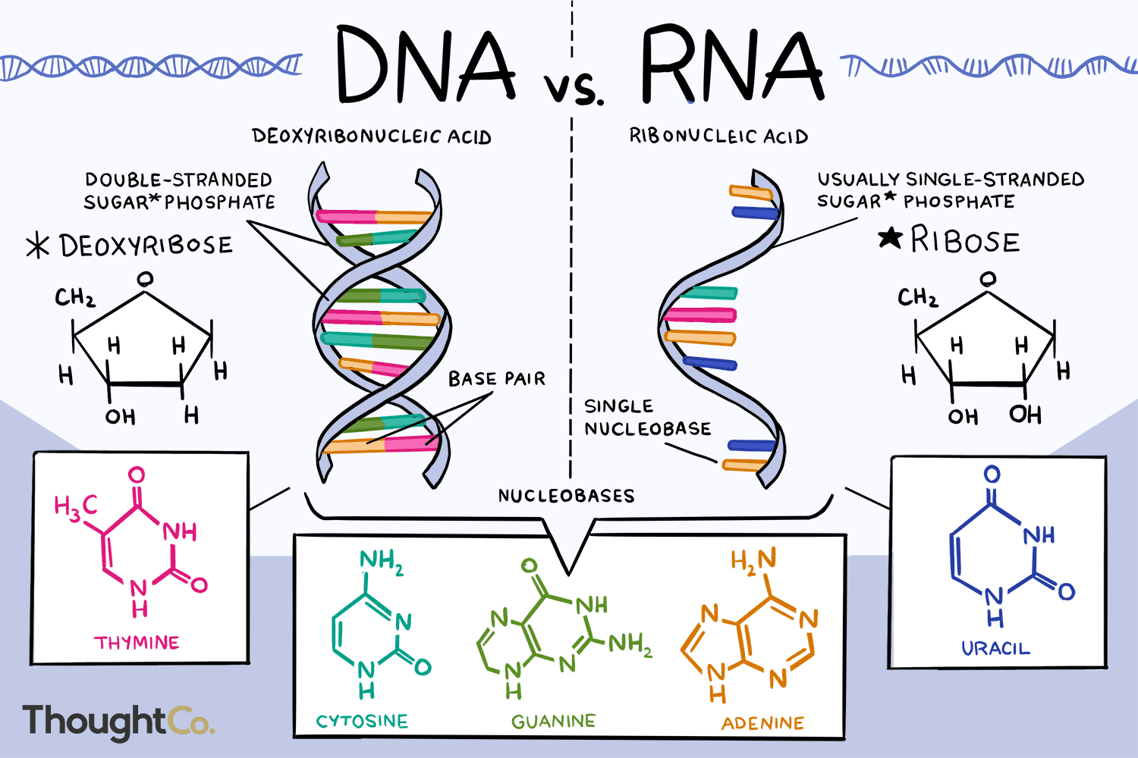

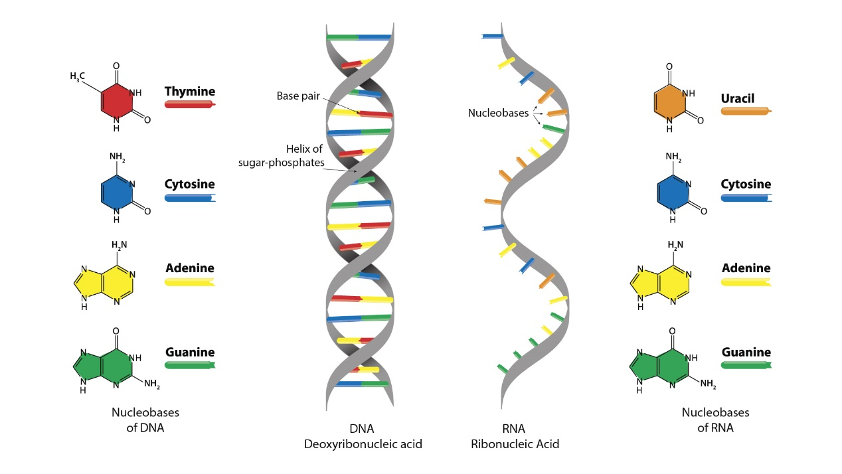

DNA

[cytosine](https://en.wikipedia.org/wiki/Cytosine) [C], [guanine](https://en.wikipedia.org/wiki/Guanine) [G], [adenine](https://en.wikipedia.org/wiki/Adenine) [A] or [thymine](https://en.wikipedia.org/wiki/Thymine) [T]

**Deoxycytidine**

**Deoxyguanosine**

**Deoxyadenosine**

**Thymidine (deoxythymidine)**

---------------------------------

RNA

[cytosine](https://en.wikipedia.org/wiki/Cytosine) [C], [guanine](https://en.wikipedia.org/wiki/Guanine) [G], [adenine](https://en.wikipedia.org/wiki/Adenine) [A],  or [uracil](https://en.wikipedia.org/wiki/Uracil) [U]

**Cytidine**

**Guanosine**

**Adenosine**

**Uridine**

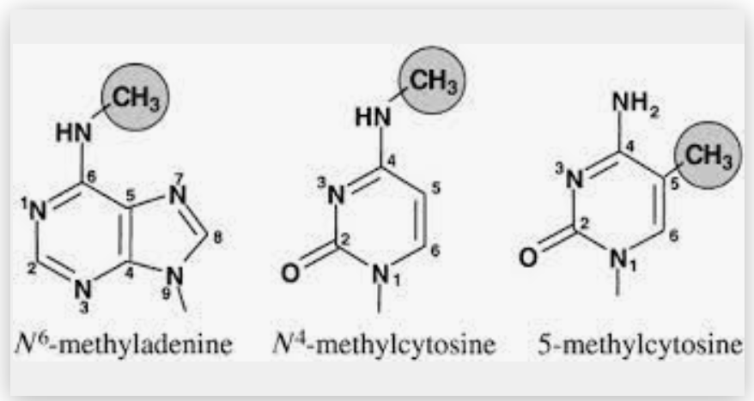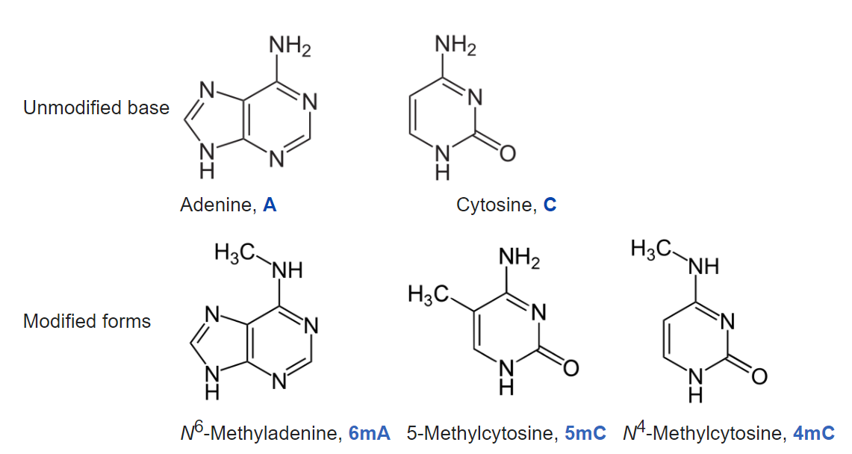

-------------------

i6mA-stack

i6mA-stack: A stacking ensemble-based computational prediction of DNA N6-methyladenine (6mA) sites in the Rosaceae genome

----------------

SpineNet6mA

SpineNet6mA: A Novel Deep Learning Tool for Predicting DNA N6-Methyladenine Sites in Genomes

----------------------

iDNA6mA

iDNA6mA: Intelligent Computational Model For Identification of DNA N6-methyladenine Sites in The Rice Genome

--------------------

i6mA-DNC

i6mA-DNC: Prediction of DNA N6-Methyladenosine Sites in Rice Genome Based on Dinucleotide Representation Using Deep Learning

-------------------

DNA6mA-MINT

DNA6mA-MINT: DNA-**6mA** Modification Identification Neural Tool

----------------------

iIM-CNN

iIM-CNN: Cross-Species m6A identification using Convolution Neural Network

--------------------------

pm6A-CNN

pm6A-CNN: A CNN-based RNA N6-methyladenosine site predictor for multiple species using heterogeneous features representation

-------------------

iN6-Methyl

iN6-Methyl : Identifying RNA **N6-methyladenosine** sites using deep learning mode via Chou's 5-step rules and Chou's general PseKNC

https://en.wikipedia.org/wiki/N6-Methyladenosine

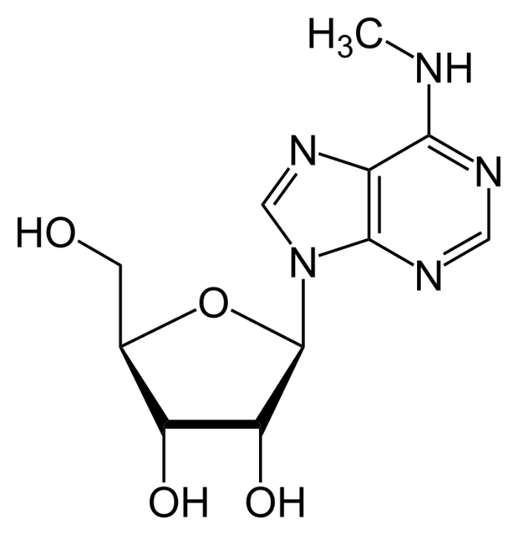

----------------

DNC4mC-Deep

DNC4mC-Deep: Identification and analysis of DNA N4-Methylcytosine sites based on Different Encoding Schemes By Using Deep Learning

----------------

4mCCNN

4mCCNN: Identification of **N4-Methylcytosine** Sites in Prokaryotes Using Convolutional Neural Network

https://en.wikipedia.org/wiki/DNA_methylation

-------------------

XG-ac4C

Identification of **N4-acetylcytidine (ac4C)** in mRNA by using eXtreme Gradient Boosting method with electron-ion interaction pseudopotentials

